**Image Analysis and Processing**

**1st set of Exercises**

**13/04/2025**

It is critical to explain your choices and provide comments for the outputs (intermediate and final). Provide your answers in a Jupyter or colab notebook.

# Exercise 1

1. Explain the impact of the following transformation function on a grayscale image, in terms of intensity values and brightness.
2. Verify your answer by a applying the transformation on an image of your choice (include input/output images in your answer)

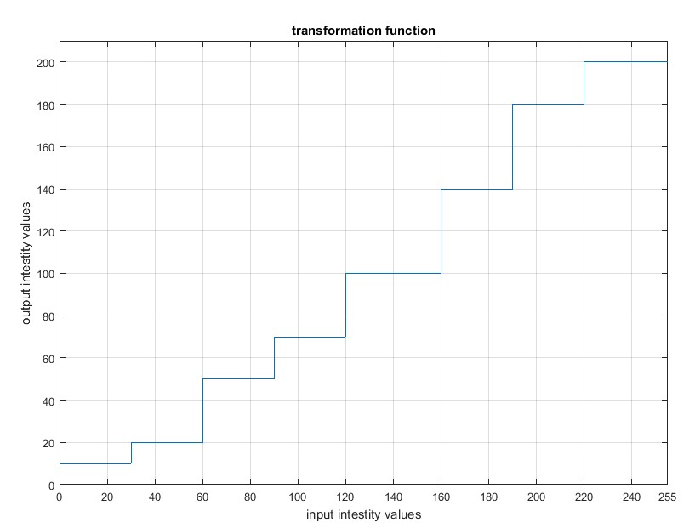

# Exercise 2

Propose a method for enhancing the image “**nature_dark_forest.jpg**” in terms of the perceived light and color.

# Exercise 3

Propose a method for improving the image “**pollen-500x430px-96dpi.jpg**” in terms the perceived brightness.

# Exercise 4

Propose a method for sharpening the image “**First-photo-of-the-moon-from-Chandrayaan2_ISRO.jpg**”.

# Exercise 5

One combined spatial enhancement methods (e.g. arithmetic operations, gray level transformations, and/or sharpening spatial filters) to convert “**image_1**” to “**image_2**”.

1. Try to guess the processing steps she adopted. [Note the dynamic range and brightness of the enhanced image, and the noise introduced.]
2. Propose a pipeline of processes with the aim of approximating “**image_1**” starting from “**image_2**”.

# Exercise 6

1. Find the main edges of image11.jpg.
2. Estimate the angle (with respect to the horizontal axis) of the diagonal edges of the roof.
3. Find the corners of the image11.jpg.
4. Based on the detected corners, locate the windows.

# Exercise 7

1. Estimate the angle with respect to the horizontal axis of the billiard cue in image31.jpg. To verify your answer, rotate the input image accordingly. The result should be similar to image32.jpg.

***Hint:*** *Note that the billiard cue is the only object with straight edges.*

1. Combine image31.jpg and image32.jpg to generate an image similar to image 33.jpg. ***Hints:***
   * *the billiard cue is the only object that matches to the pattern of a very long horizontal line.*
   * *it is very likely that the billiard cue is connected to a ball in a binary representation of the image (and it would be useful to separate these objects)*